Antonio Scalfaro

11/25/2023

SDEV 300 / 7381

Lab 6 – Web Application

This week’s lab was to create a web application about a topic of our choosing. I chose to create a web application about my three favorite baseball players. All of the testing for this application is done manually and there are no test cases for it. The site contains 4 pages, the home page and one page for each player. Each player’s page contains a hyperlink to their Baseball Reference stats page, an image, a small excerpt, and a bulleted list of some career highlights. On the home page, there is a hyperlink to my personal site I built over a year ago and the date time is displayed at the bottom. All hyperlinks link to a new window instead of redirecting in the current window. All links in the nav bar work as intended. The biggest takeaways from this lab are more about structure and the importance of attention to detail. Creating web applications can be difficult in one sense and easy in another. It is difficult to keep track of all the routes and classes, much like keeping track of a series of intertwined wires, but the code is relatively easy to write. I ran into some issues with displaying images, which was a simple issue of not getting the relative path correct and having the image folder outside of the static folder, but this took me some time to figure out. I have good experience building web applications, so this was a great refresher experience and also valuable to accomplish in Python (previously used JavaScript). And of course, using HTML and CSS (like all code) gets easier and better the more you do it. The Pylint score for this application was 10/10.

**Landing Page:**

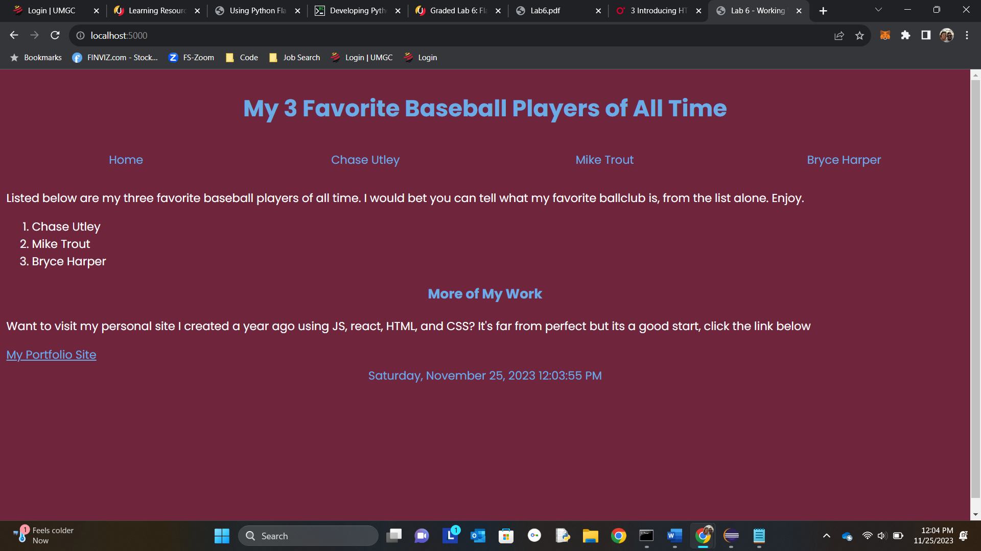

**Utley Page:**

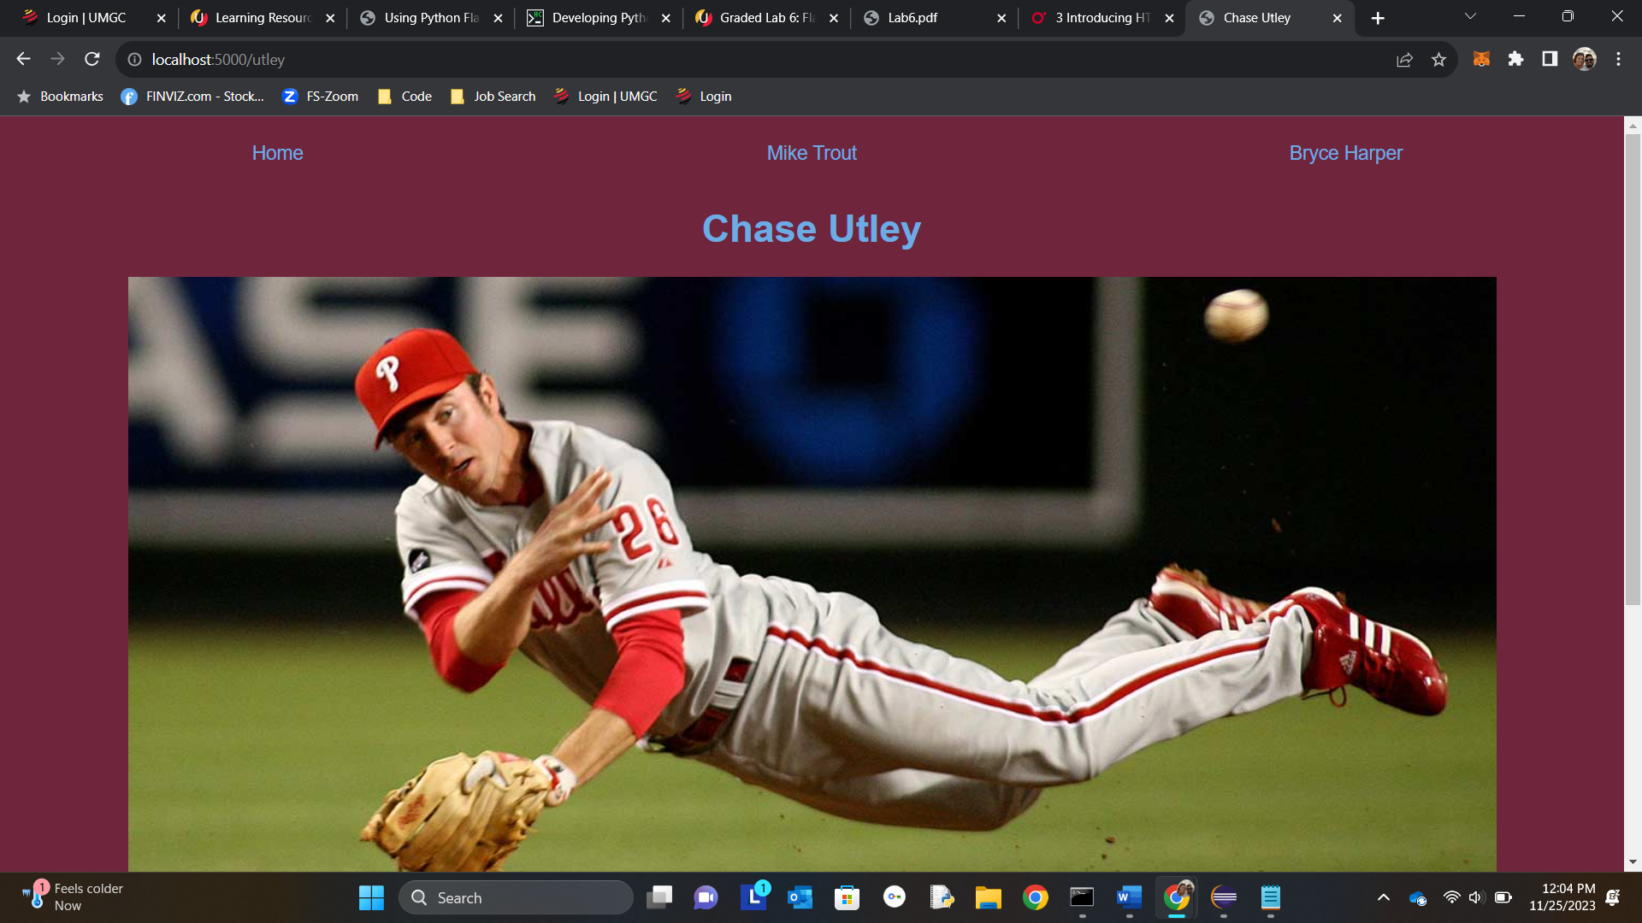

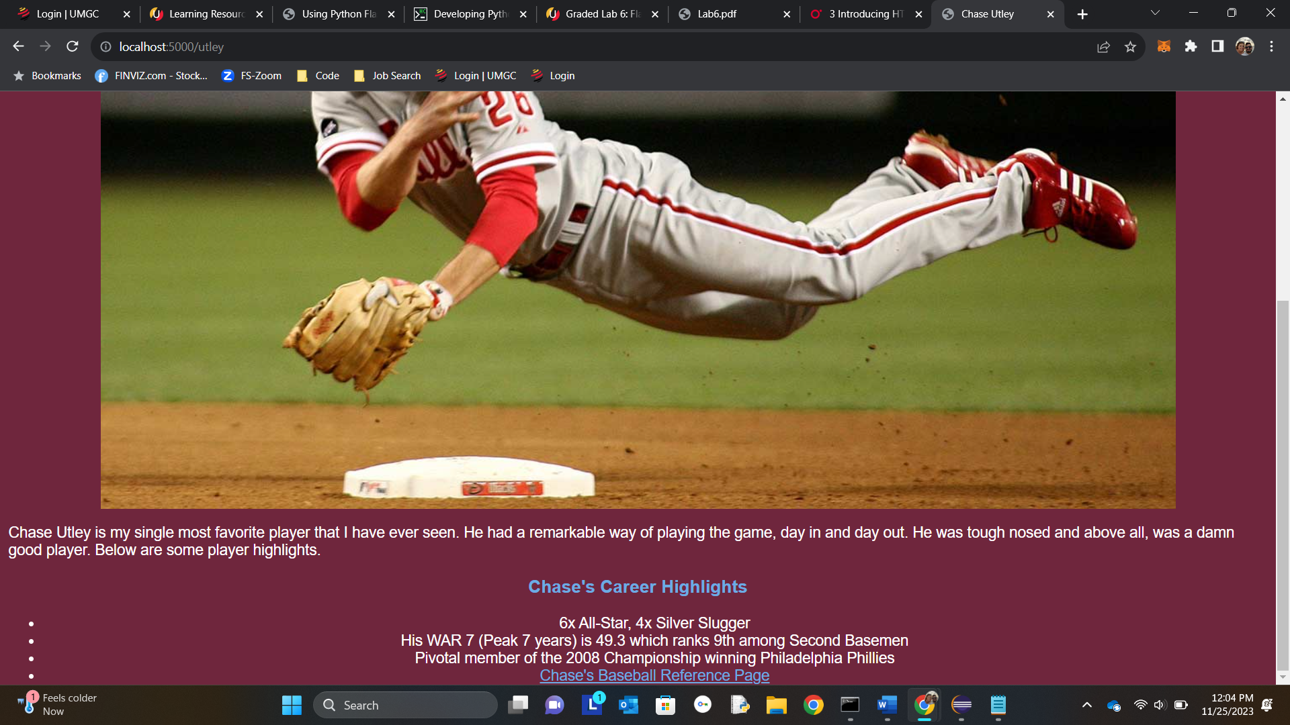

**Trout Page:**

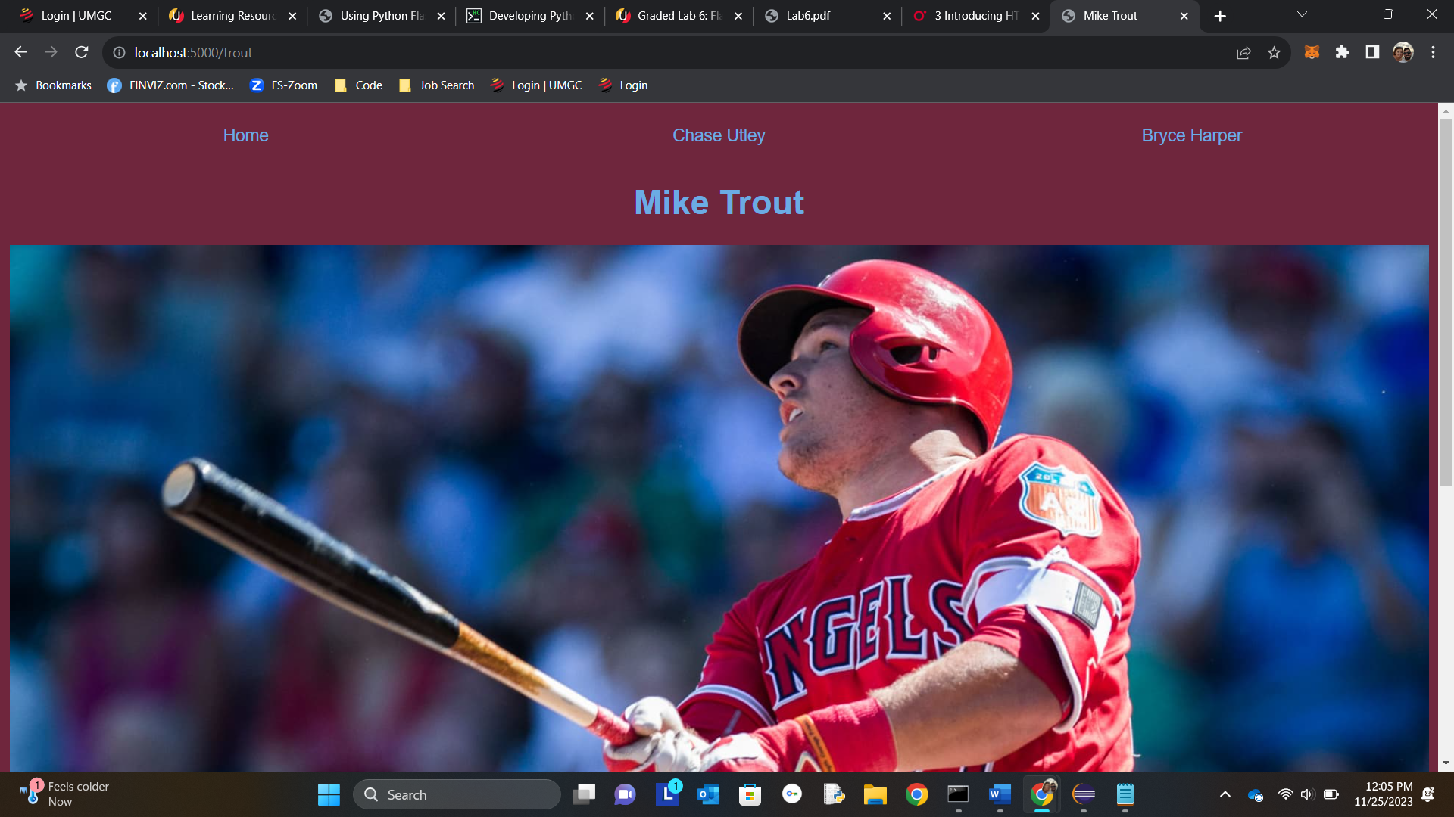

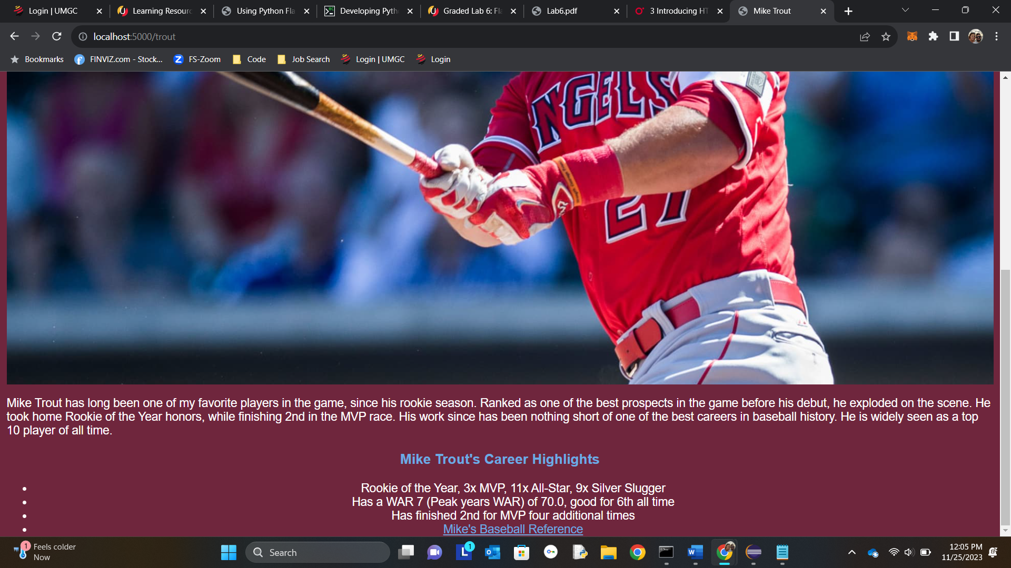

**Harper Page:**

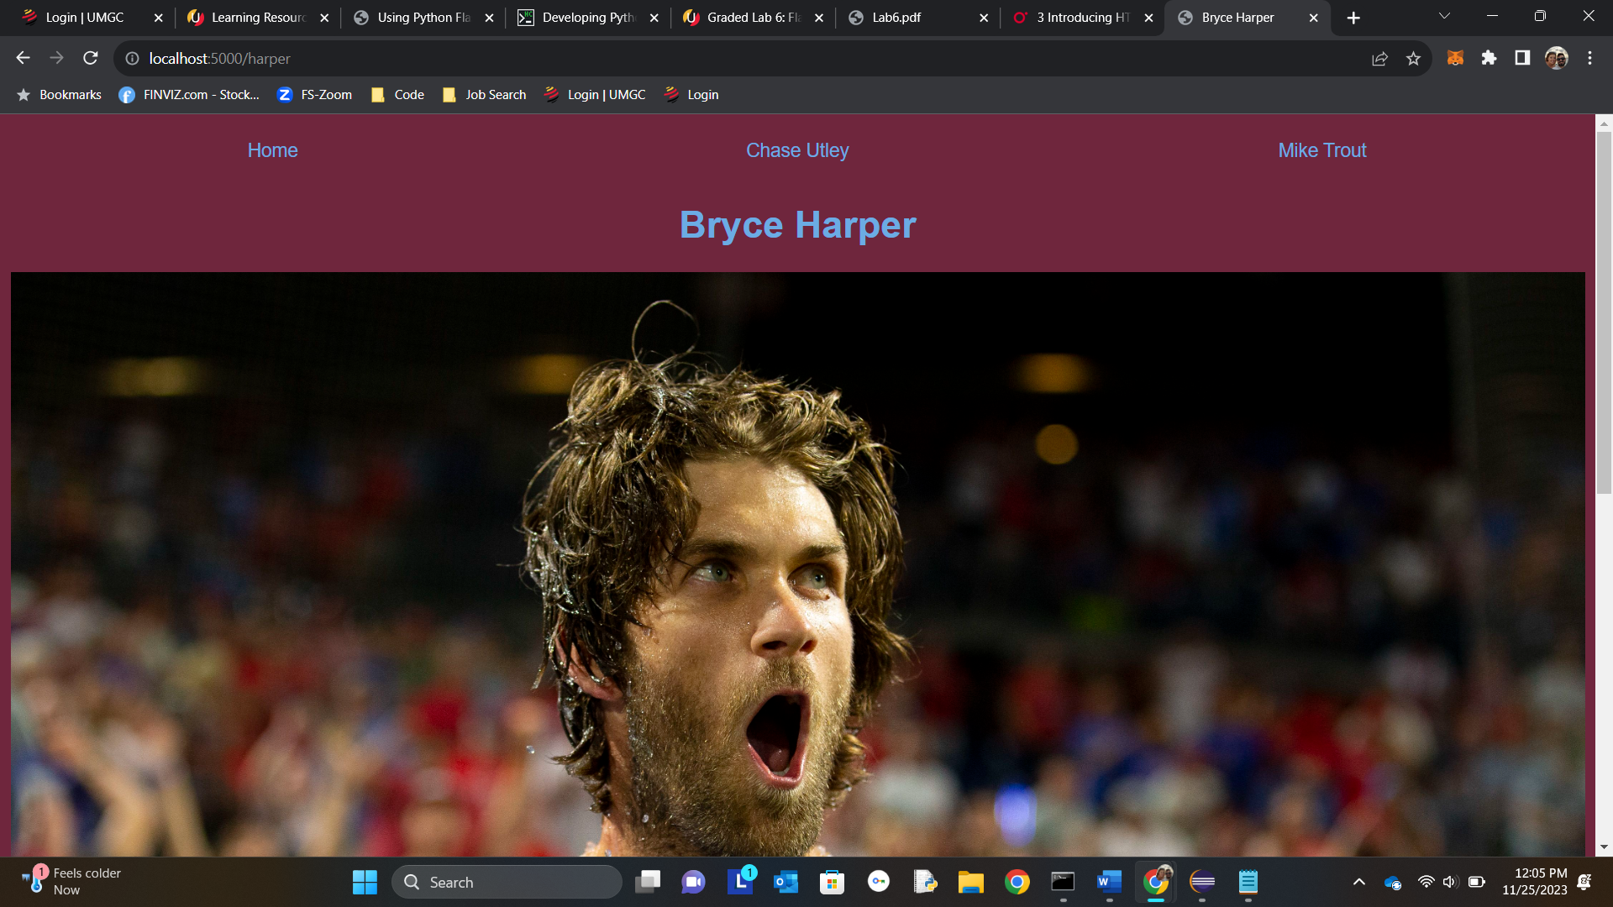

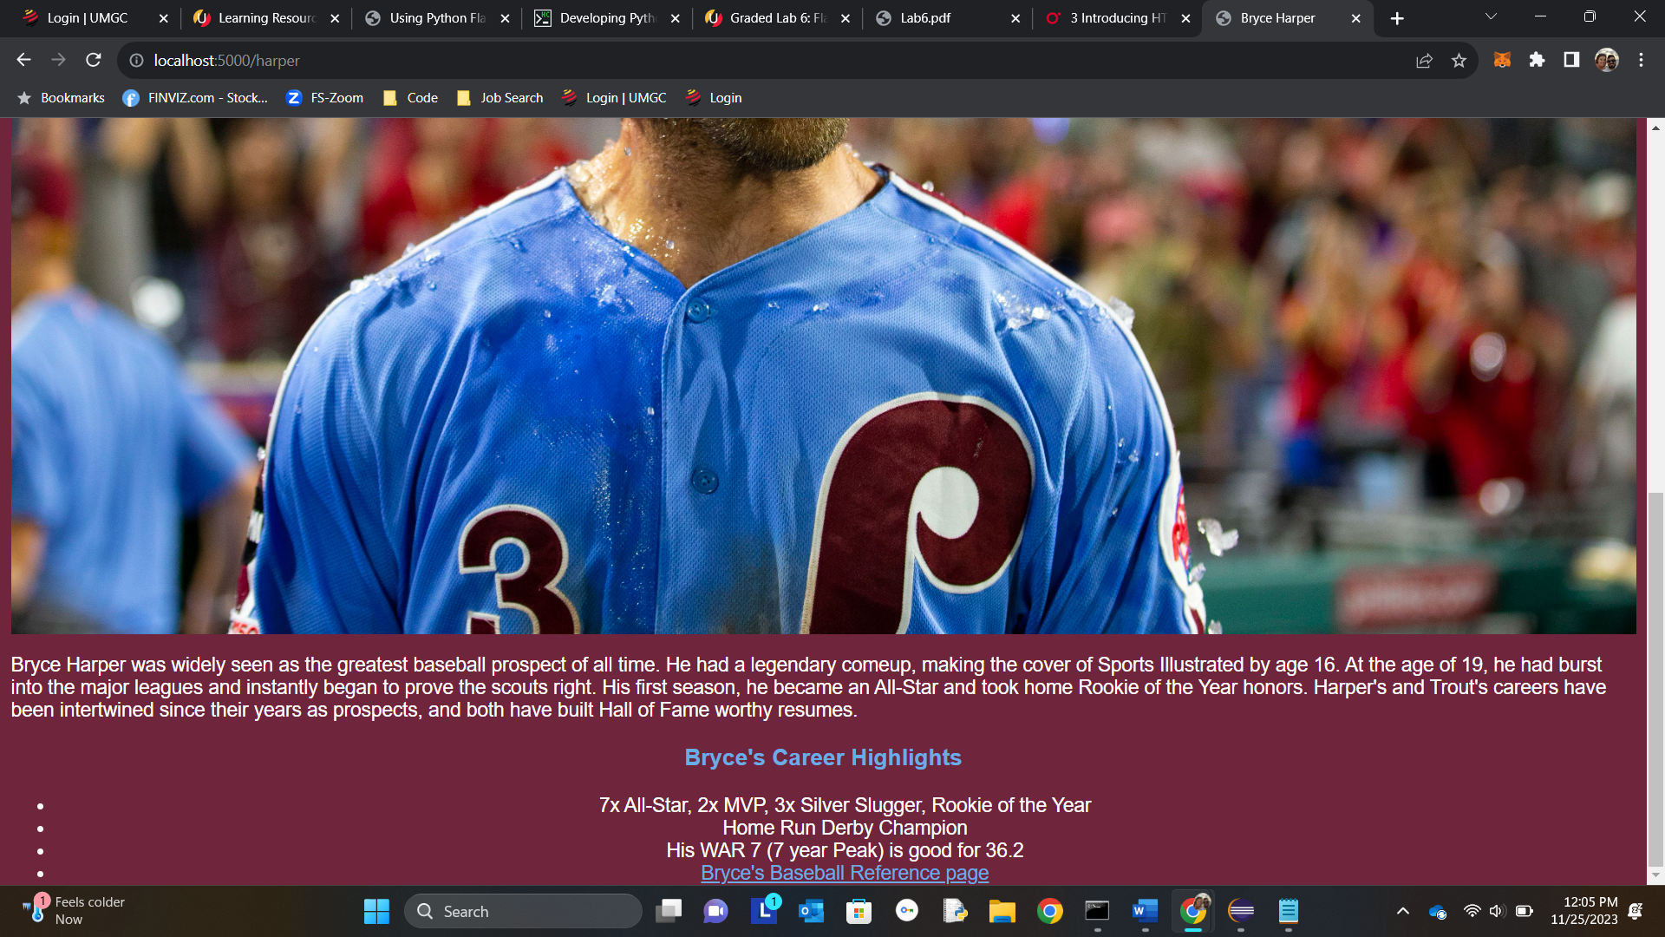

**Pylint:**

